**TOPIC: Retrieving 3D structure from PDB**

**Aim: Retrieving 3D structure from PDB:**

To perform the current practical, you’ll be needing two things

1. PyMOL (software)
2. Protein in .pdb format

* **Installing PyMOL Software**

First, we need to install PyMOL. To do so open google and simply search PyMOL

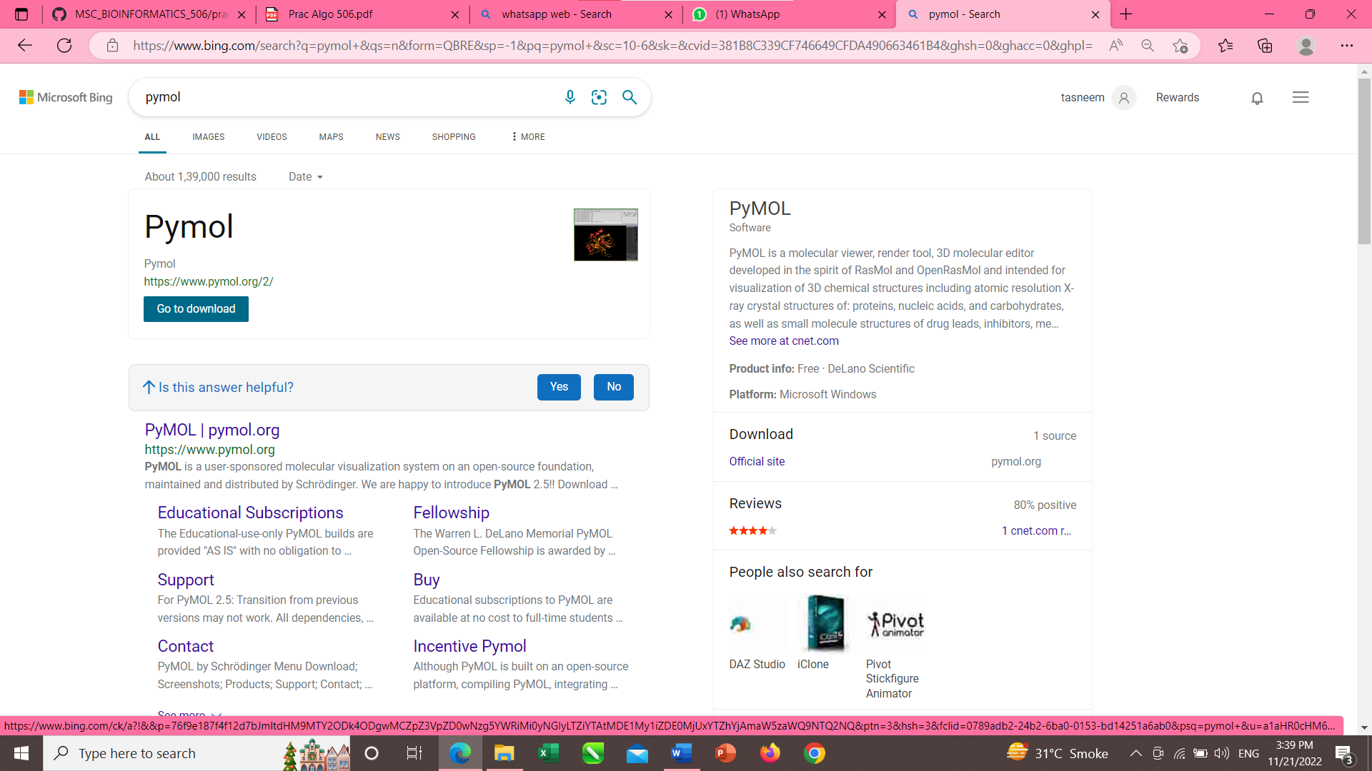

Open the first link and click Download Now

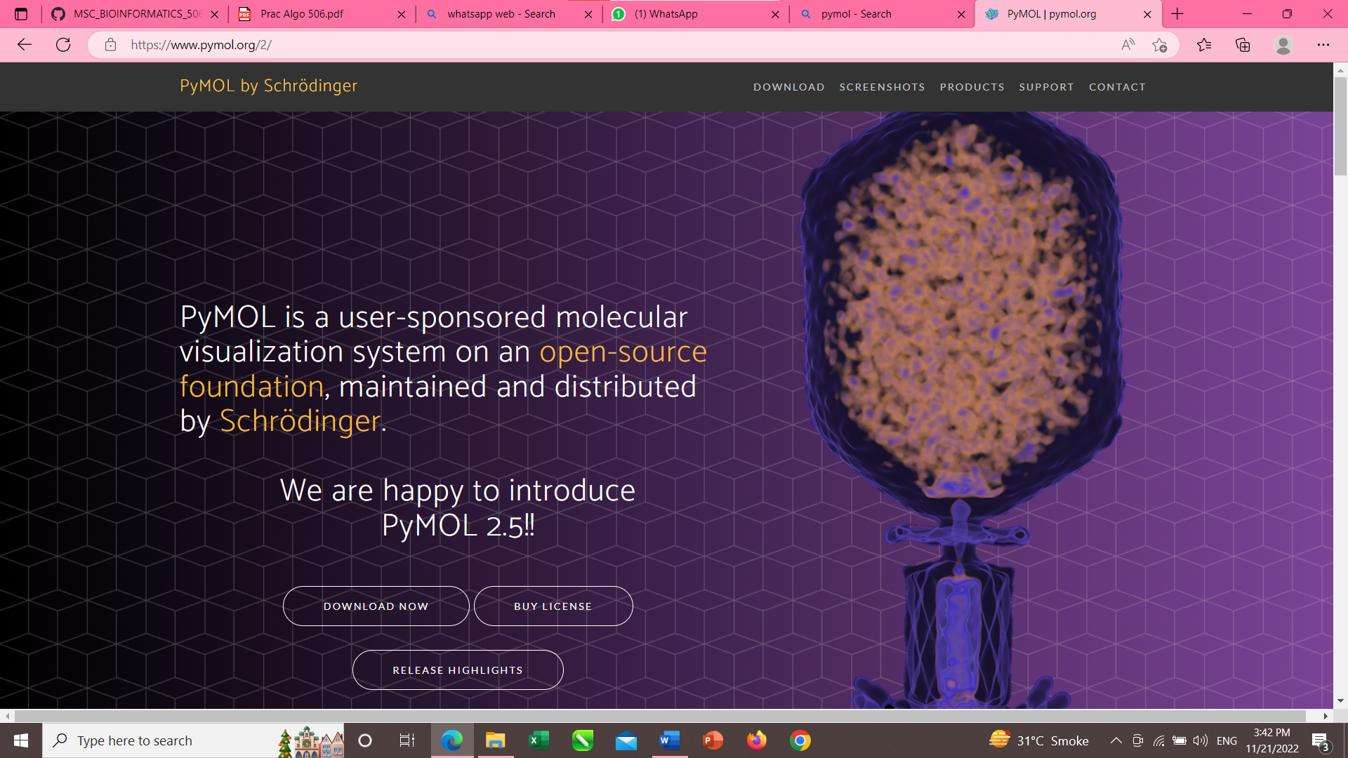

* When done downloading install the software.
* This is how the interface of the software looks like.

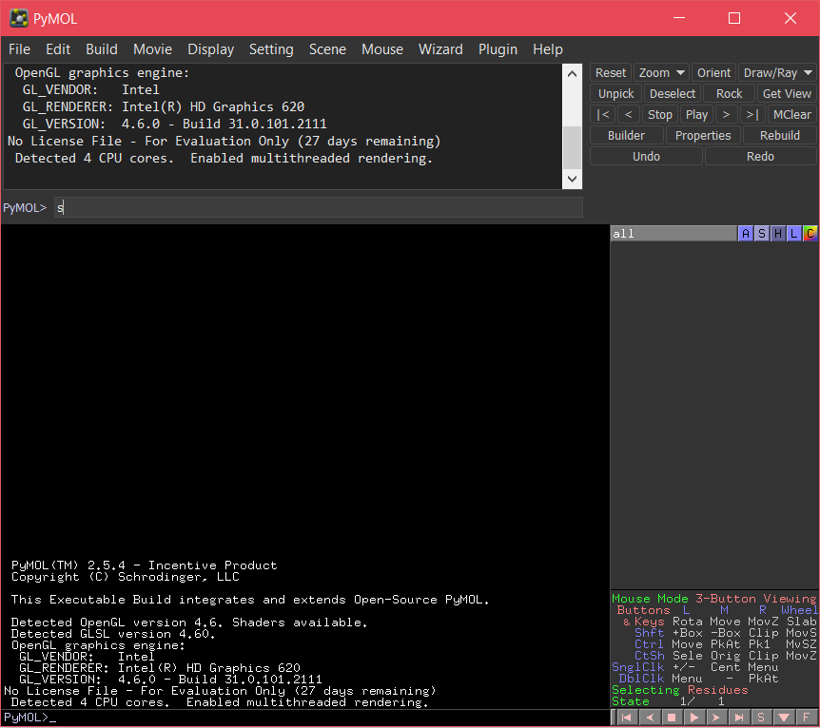

* **Downloading Protein in .pdb format**

To download Protein open, google and search pdb or simply visit <https://www.rcsb.org/>

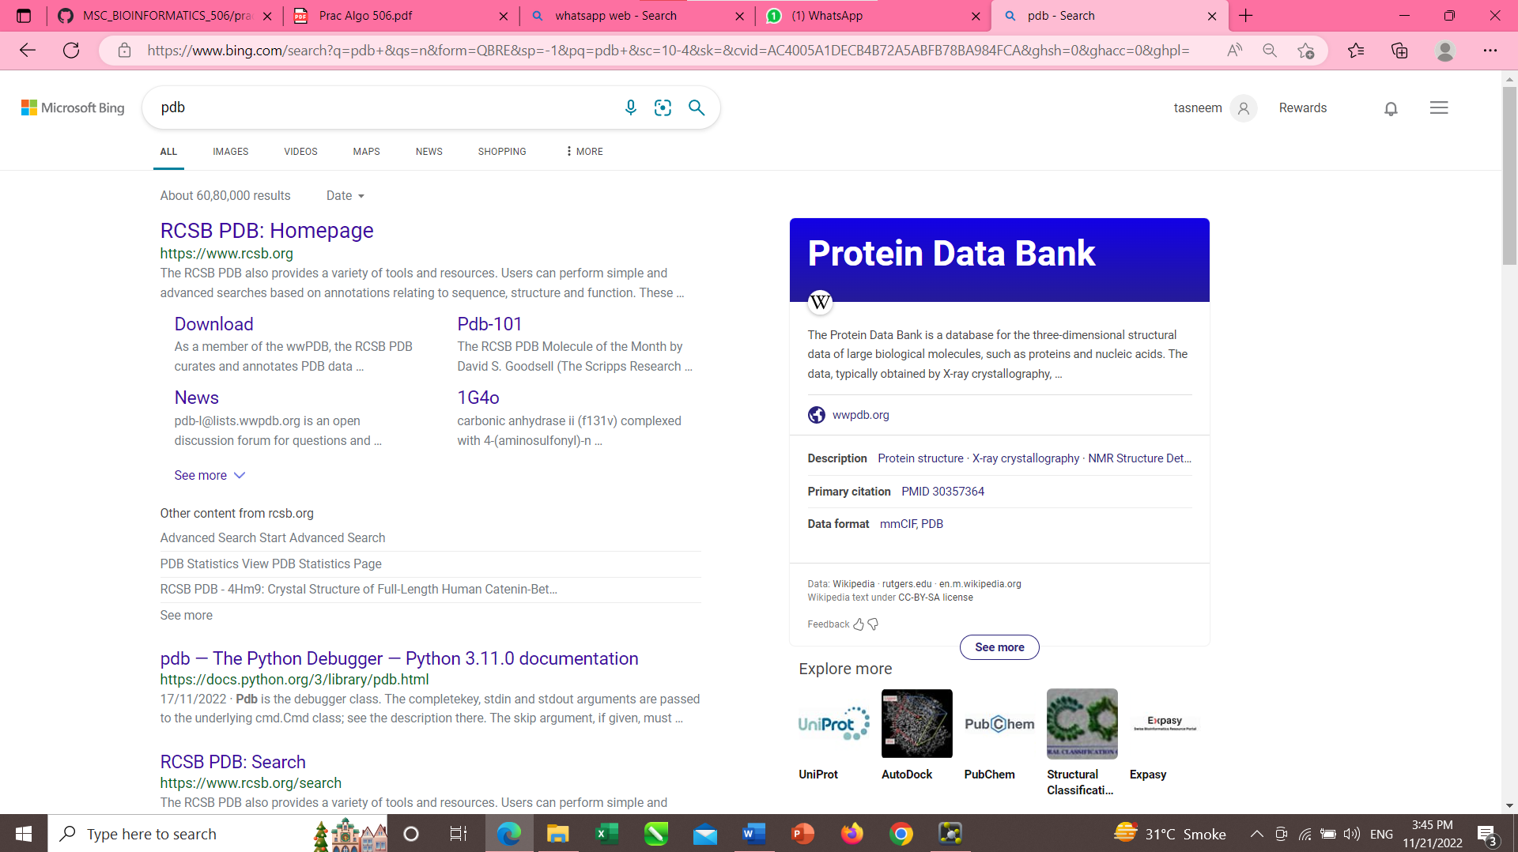

* Open the first link named “RCSB PDB: Homepage”
* On the search bar search for “MYOSIN”

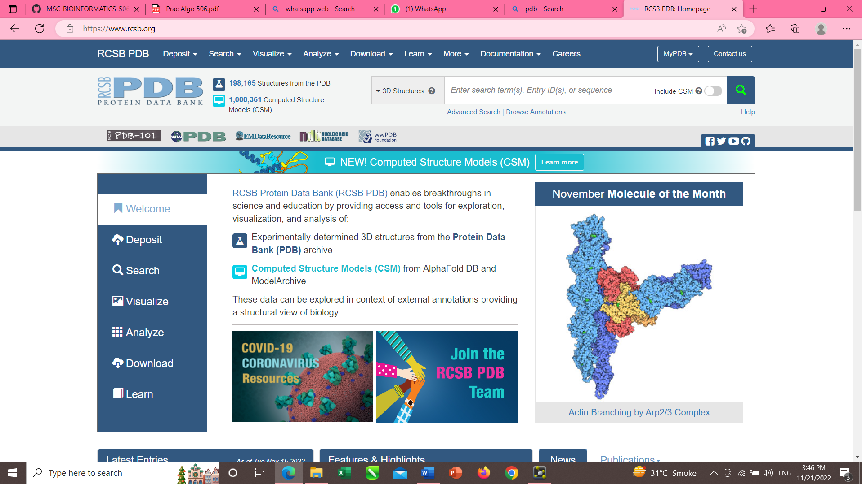

* You’ll see all the proteins listed below like this

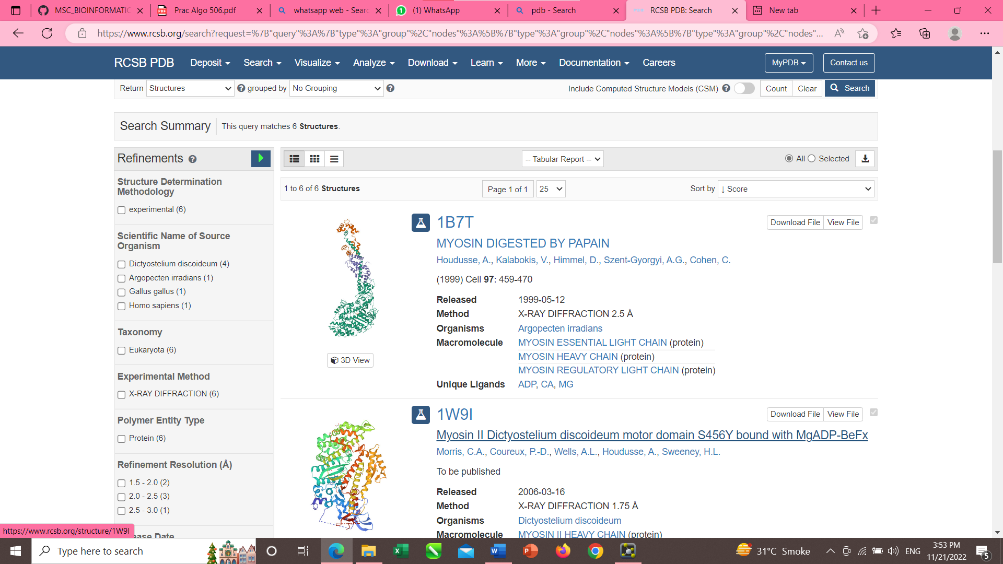

* Scroll down until you find “1W9I” and open it or you can directly search for “1W9I”

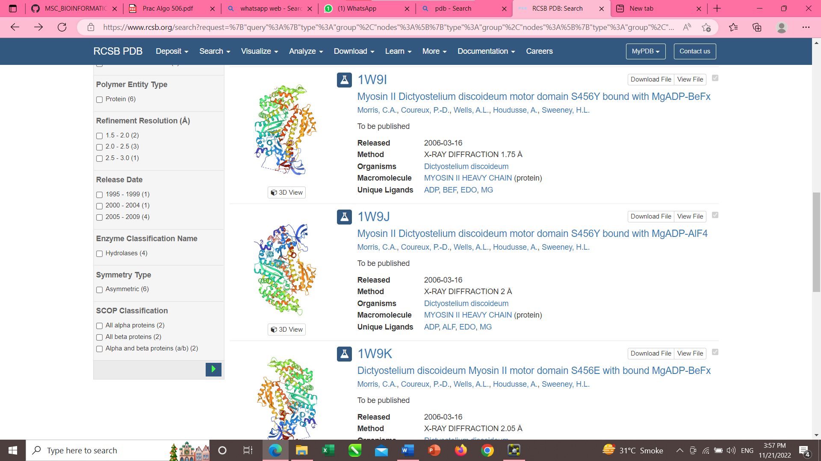

* On the right-hand side, you’ll the download option. Click on it and download as PDB format

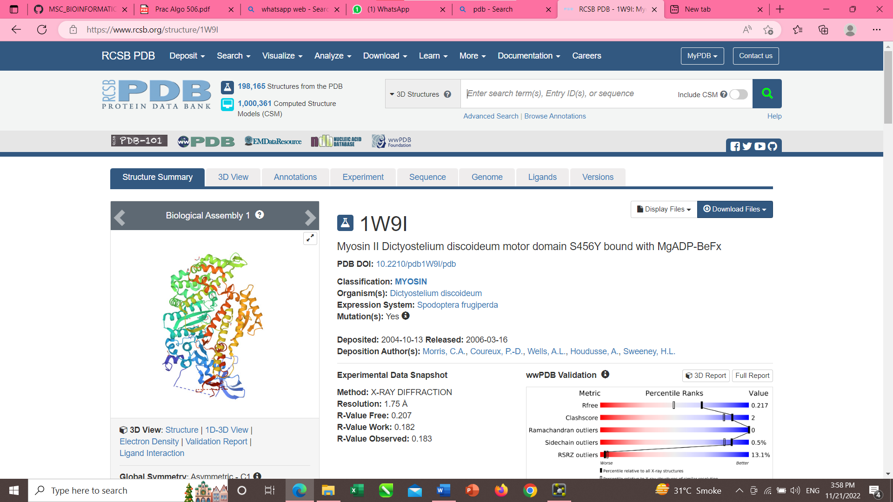

* Now that protein is downloaded open PyMOL and on top left corner click File > open

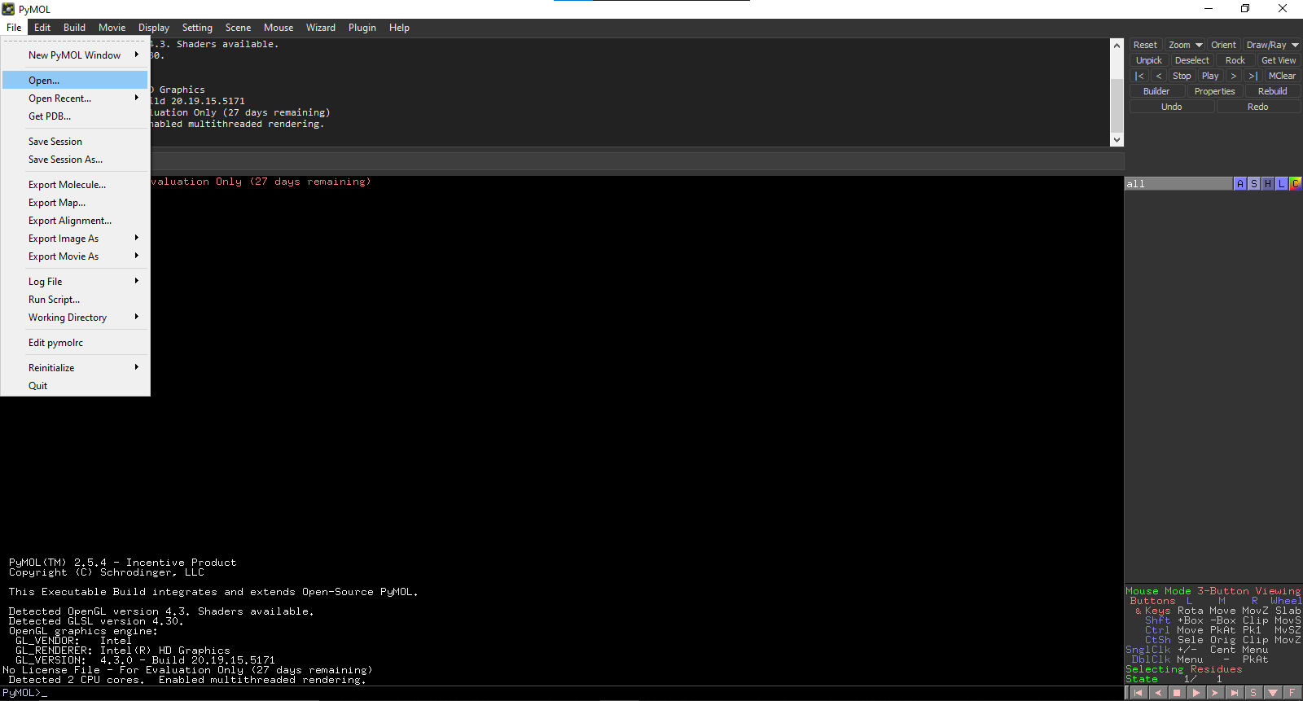

* Now browse for the file you just downloaded (1w9i.PDB)

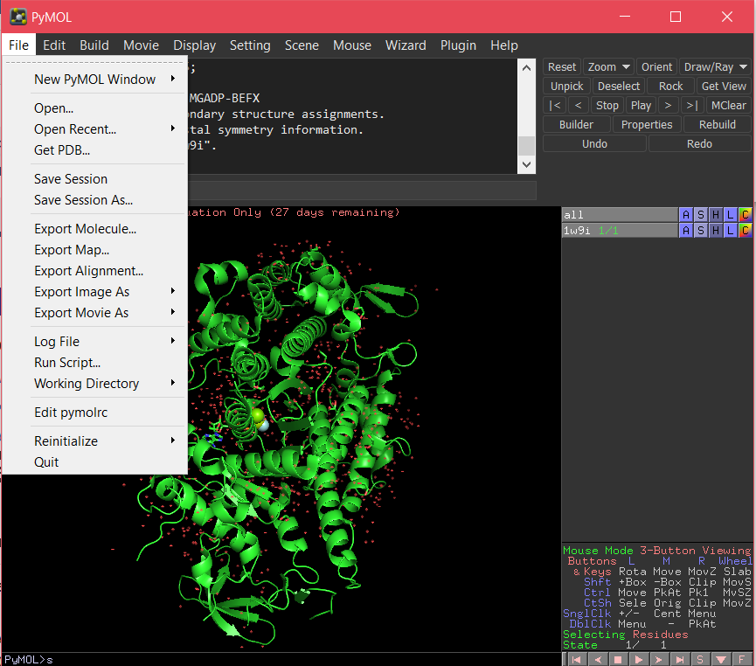

* This is how the screen of imported file looks like

